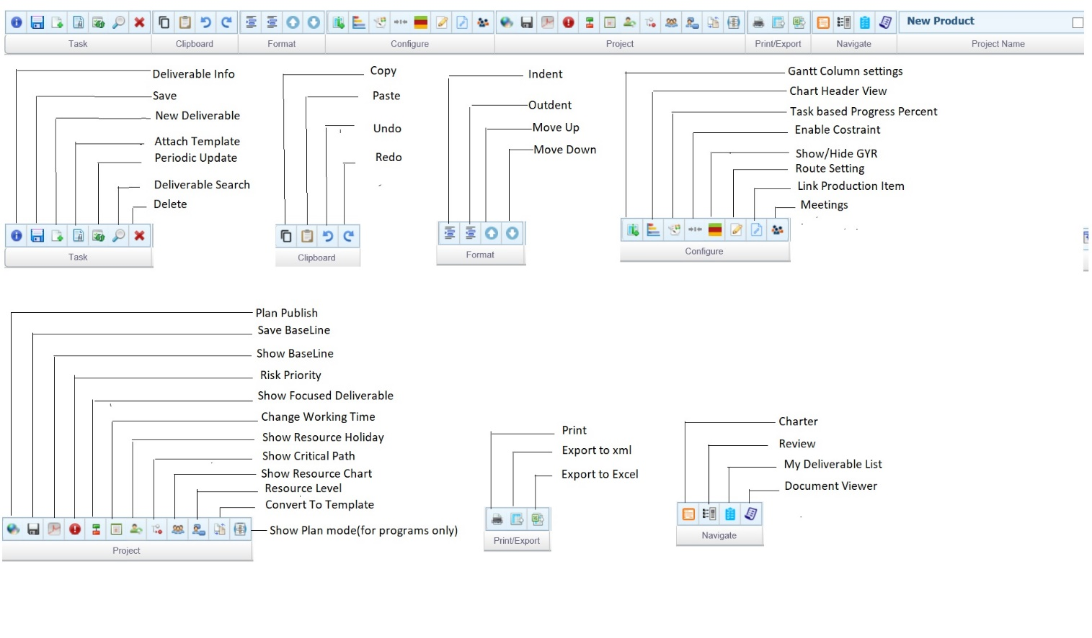

**TASK**

 - **Deliverable Info** - This icon is used to add information for the Deliverable

 - **Save** – To save a Project Plan

- **New Deliverable** -To add a new deliverable in the project plan

- **Attach Template** -To add a phase or task from an existing template.

-**Periodic update** - To view daily task details entered by team members. This is used by the project members.

 - **Deliverable Search** – To Search for a deliverable in the project based on the filters selected

 -**Delete** - To delete a selected deliverable.

CLIPBOARD

 - **Copy** – To Copy the selected deliverable

- **Paste** – To paste the copied deliverable.

 - **Undo** – To undo the deliverable details

 - **Redo** – To redo the deliverable details

FORMAT

 - **Indent** -Select a deliverable and click to indent the row. The selected deliverable becomes a task within a main task.

 - **Outdent** - Select a deliverable and click to out dent the row. The selected deliverable becomes an independent task.

 - **Move Up** – To Move up the selected deliverable

 - **Move Down** – To move down the selected deliverable

CONFIGURE

 - **Gantt Column Settings** – To show / hide more columns

- **Chart Header View** –To select and display the chart header view

- **Task based Progress Percent** – To view the task driven estimation and Disable to view the effort driven estimation.

- **Enable Constraint** - Click to enable all task constraints.

- **Show / Hide GYR** - shows the GYR rating of the deliverables

- **Route Setting -** To create a review route for the entire project, for all deliverables

- **Link Production Item** – To link a production item to the project

 - **Meeting** - To create meeting requests for deliverables.

PROJECT

 - **Plan Publish** - To publish the project plan in DocPro

- **Save Baseline** – Click to Save a Baseline

- **Show Baseline** - This icon is used to add information for the Deliverable - Click to view the saved the baseline

- **Risk Priority** – To add a risk to a deliverable

- **Show Focussed Delievrable** - To view the focused deliverables

- **Change Working time** - To change the working time of a project or a member. Mark the non-working days, if any.

- **Show Resource Holiday -** To view the non-working days of resources.

- **Show critical Path** - To view the critical path in the deliverable

- **Show resource chart** - To view the resource chart. You can view the overlapping tasks

-**Resource level** - To adjust overlapping task dates

- **Convert to template** - To convert and save the project as a template.

- **Plan Mode** – To toggle between program view and project view

PRINT / EXPORT

- **Print** - To print the project plan.

- **Export to xml** - To export the project plan to xml format

- **Export to Excel** - To export the project plan to Excel format

NAVIGATE

- **Charter** – To navigate to the project charter

- **Review** - To navigate to the project review page

- **My deliverable list** - To navigate to the my deliverable list.

- **Document viewer** - To navigate to the document viewer.